**CAR RENTAL SYSTEM**

A

Minor Project Report

Submitted in partial fulfillment of the requirement for the award of degree of

**Bachelor of Technology**

In

**Computer Science & Engineering**

Submitted to

**RAJIV GANDHI PROUDYOGIKI VISHWAVIDYALAYA,**

**BHOPAL (M.P.)**



**Guided By Submitted By**

Prof.Rashmi Vijaywargiya Kartik Patil (0875CS181070)

Kapil Patil (0875CS181069)

Mayank Wadhwa (0875CS181082)

Himanshu Mandloi (0875CS181060)

**DEPARTMENT OF COMPUTER SCIENCE & ENGINEERING**

**SHIVAJIRAO KADAM INSTITUTE OF TECHNOLOGY & MANAGEMENT – TECHNICAL CAMPUS, INDORE (M.P.) - 452020**

**2020-2021**

Declaration

I hereby declared that the work, which is being presented in the project entitled **Car Rental System** partial fulfillment of the requirement for the award of the degree of **Bachelor of Engineering**, submitted in the Department of Computer Science & Engineering at **Shivajirao Kadam Institute of Technology & Management – Technical Campus, Indore** is an authentic record of my own work carried under the supervision of “**Prof. Rashmi Vijaywargiya**”. I have not submitted the matter embodied in this report for award of any other degree.

Kartik Patil (0875CS181070)

Kapil Patil (0875CS181069)

Mayank Wadhwa (0875CS181082)

Himanshu Mandloi (0875CS181060)

Prof.Rashmi Vijaywargiya

**Supervisor**

Project Approval Form

I hereby recommend that the project **Car Rental System** prepared under my supervision by **Kartik Patil (0875CS181070) Kapil Patil (0875CS181069) Mayank Wadhwa (0875CS181082) Himanshu Mandloi (0875CS181060)** be accepted in partial fulfillment of the requirement for the degree of Bachelor of Engineering in Computer Science & Engineering.

Prof. Rashmi Vijaywargiya

**Supervisor**

Recommendation concurred in 2020-2021

Prof. Virendra Dani

**Project In-charge**

Prof. Kailash C. Bandhu

**Project Coordinator**

**Shivajirao Kadam Institute of Technology & Management – Technical Campus**

Department of Computer Science & Engineering



Certificate

The project work entitled **Car Rental System** submitted by **Kartik Patil (0875CS181070) Kapil Patil (0875CS181069) Mayank Wadhwa (0875CS181082) Himanshu Mandloi (0875CS181060)** is approved as partial fulfillment for the award of the degree of Bachelor of Engineering in Computer Science & Engineering by Rajiv Gandhi Proudyogiki Vishwavidyalaya, Bhopal (M.P.).

**Internal Examiner External Examiner**

Name:………………. Name: ……………..

Date: …./…/……….. Date: …./…/………..

Acknowledgement

With boundless love and appreciation, we/I would like to extend our/my heartfelt gratitude and appreciation to the people who helped us/me to bring this work in reality. We/I would like to have some space of acknowledgement for them.

Foremost, our/I would like to express our/ my sincere gratitude to our/my supervisor, **Prof. Rashmi Vijaywargiya** whose expertise, consistent guidance, ample time spent and consistent advices that helped us/me to bring this study into success.

To the project in-charges **Prof.Virendra Dani** for their constructive comments, suggestions, and critiquing even in hardship.

To the honorable **Prof. Prashant Lakkadwala**, Head, Department of Computer Science & Engineering for his favorable responses regarding the study and providing necessary facility.

To the honorable **Dr. Sanjay T. Purkar**, Director, Shivajirao Kadam Institute of Technology & Management – Technical Campus, Indore for his unending support, advises and effort to make possible.

Finally, I/we would like to pay my/our thanks to faculty members and staff of Department of Computer Science & Engineering for their timely help and support.

We/I also like to pay thanks to our/my **parents** for their eternal love, support and prayers. Without them it is not possible.

Kartik Patil (0875CS181070)

Kapil Patil (0875CS181069)

Mayank Wadhwa (0875CS181082)

Himanshu Mandloi (0875CS181060)

Abstract

Our Aim is to design and create a data management System for a car rental company. This enables admin can rent a vehicle that can be used by a customer. By paying the money during a Specified Period of time. This system increases customer retention and simplify vehicle and staff Management in an efficient way.

This software car Rental System has a very user friendly interface. Thus the users will feel very easy to work on it. By using this system admin can manage their rental, payment, employment issues and vehicle issues such as and insurance. The car information can be added to the system. Or existed car information can be edited or deleted too by Administrator. The transaction reports of the car rental system can be retrieved by the admin, when its required .Thus, there is no delay in the availability of any car information, whenever needed, car information can be Captured very quickly and easily.

The customers can also use the system to get car rent. The customer should create a new account before logging in or he / she can log into the System with his/her created account. Then he/she can view the available cars in a branch and make a reservation for a Car. This system will helpful to the admin as well as to the customer also.

**Table of Content**

Chapter 1: Introduction

1.1 Rationale

1.2 Goal

1.3 Objective

1.4 Methodology

1.5 Role

1.6 Contribution of Project

1.6.1 Market Potential:

1.6.2 Innovativeness

1.6.3 Usefulness

1.7 Report Organisation

Chapter 2:Requirement Engineering

2.1 Requirement Collection

2.1.1 Functional Requirements

2.1.2 Non-Functional Requirements

Chapter 3:Analysis and Design

3.1 Use-case Diagrams

3.2 Activity Diagrams

3.3 Sequence Diagram

3.4 E-R Diagram

3.5 Database Design

3.5.1 Logical Structure of Data……………………………………………………………

Chapter 4:Construction

4.1 Validation

4.2 Testing

4.2.1 Black Box Testing

Conclusion & Future Works……………………………………………………………………………...

Appendix A (Snapshot)…………………………………………………………………………………..

References………………………………………………………………………………………………...

CHAPTER 1: INTRODUCTION

1.1 Rationale –

Problem in Existing System –

There are some customers who faced a problem in choosing car to be rented which are suitable with some of the important requirements. Following are some problems in existing system –

1] To rent a car a prospective renter must first go to the nearest office to register as a client.

2] One of the main and general problems is TIME. Often Office gets closed early at evening and this system will overcome all its defects.

3] Most of the car renting company are using traditional way to deal with the customer. Which are time and labour consuming? An existing system can provide manually paper work or excel sheet to track the booking and registered vehicles details.

Improvement over Existing System -

Important features that is added in this project which will eradicate existing system’s problems are –

1] Can see all details of vehicle online and anytime.

2] Better UI for better experience.

3] Use of better and optimum Algorithms for FAST response and use.

4] Maintenance will be easy which is a major headache in traditional one.

1.2 Goal –

The propose system has been developed in keeping mind the following goals:

1] View tracking history and update personal information

The registered members are allowed to view and track the reservation history. Besides, they are able to update their personal information if necessary from time-to-time.

2] View updated and latest travel guide

The registered and unregistered users are able to view the latest and updated information about the India’s travel guide.

3] View cars with affordable pricing

The rental pricing for each type of cars are clearly listed in the propose system to enable the registered and unregistered users to compare themselves with their competitors. The listed pricing are affordable for employed and unemployed employees or citizens who their incomes range are between low-medium levels to upper-upper level.

4] Post suggestions, comments, and complaints

The registered and unregistered users are able to post their suggestions, comments and complaints through the propose system. Therefore, the company will improve themselves from time-to-time to ensure that their customers are satisfied with their services given.

5] Secure

The propose system is provide three tier login concept. It means that different users will login with different permission or privilege. Therefore the users are able to access different functionality of the proposed system.

1.3 Objective –

Objectives of Car Rental System are as follows –

1] To computerize the car rental operations.

2] To manage all booking through computers so there will not be any mismatch across the shifts.

3] To make the proper billing for the customer.

4] The project is built at Administrative end so it ensures that only administrator can have full access to the system.

5] It tracks all details about customer.

1.4 Methodology –

The methodology which we used in the project is Waterfall Methodology.

The Waterfall methodology is the oldest methodology on this list. It is a model to manage the increasingly complex nature of software development. The Waterfall methodology is sequential. It is also heavily requirements-focused. The Waterfall method is divided into discrete stages. You start by collecting and analyzing requirements, designing the solution (and your approach), implementing the solution and fixing issue, if any.

Waterfall Methodology is best –

1] If requirements are clear-cut.

2] For easy stepwise Procedure.

3] If you don’t need to have change in requirements in mid or latter stage.

4] Provides a set of processes that are built on the principle of approval of the previous phase

1.5 Role –

Project has 2 roles – Admin, Customer .

1.6 Contribution of Project –

1.6.1 Market Potential –

A car rental or hire a car agency is a company that provides service of renting automobiles for the short-time duration. Car rental companies purchase the number of fleet vehicles and rent them to customers with a fee. ACRISS Car Classification Coding system is important factor to define the car models. The matrix to define car models consist of vehicle type, chassis type, transmission, fuel type according to which four character code is created and assigned to the car.

Economical car and executive car are major segments adding high revenue in the car rental market. The growing usage of these cars for airport service is driving the market owing to which the application segment is growing rapidly with a CAGR of 12.72% going through 2025.

→Car Rental Market: Growth Drivers

• Growth of international tourism coupled with increasing cognizance about car rental service is driving the car rental market.

• Several companies are offering mobile apps for booking rental cars or to check for their availability. Moreover, additional promotional strategies such as promotional offers, discount coupons, wallet cash are some factors inclining consumers towards cost-effective car rental services.

• Various travel agencies are promoting car rental companies that will further promote the value of the car rental market.

• Rising demand for car rental services from students and youth population for road trips, short vacation is influencing the car rental market.

→Car Rental Market: Trends

• Offering car rental on hourly basis is one of the trends in the car rental market.

• Many car rentals companies have launched the car hop service which comprises of path-breaking one way, inter-city self-drive. The service provides the option of renting a car from point A to B and again picks up a car from another city at point C from same car rental company. Due to features such as convenience travel option and flexibility, the hopping service is gaining traction from consumers in the car rental market.

• With increases in demand for cars there is a need to match the increasing supply. The increase in the mergers between car manufacturing companies and car rental companies are expanding the fleet and opportunities for both companies to leverage their business revenue.

• Luxury and premium car models always fascinate the customers. The launch of renting luxury cars service is gaining popularity among wide population. Increasing number of booking for hotel travel desk, event transportation, wedding & parties are adding high incentive in the car rental market.

• The growing options of vintage cars renting service is another factor fueling the car rental market.

• The car rental companies are focusing on merging with a local population known as peer-to-peer car sharing. People who own a car but do not use it often can merge with the rental companies to give their own car for renting service and earn the profit. The collaboration between two are gaining immense popularity in the car rental market.

The recovery of the global economy in the past decade played a significant role in the progression of the travel industry. The growing trend and consumers' interest in travel is enhancing the car rental market when companies are providing positive services and output. Some applied innovative fronts such as easy to book over mobile apps, 24x7 availability of the car, and cost affordability is driving rental cars demand. The global car rental market had a market size of $64.47 billion in 2018 and opportunities are poised growing with a compound annual growth rate (CAGR) of 11.53% during the forecast period 2019-2025.

1.6.2 Innovativeness -

Due to the advancement of technology in Car Rental, you can sit from the comfort of your home or office and make your car rental bookings. Most car rental companies have embraced this technology and are now providing a 24/7 online car rental booking platform for residents and tourists who want to rent a car. Also, most tourism and travel services now integrate the services of Rent a Car into their online platforms so that the transportation needs of their customers can be satisfied even before they set a foot in the country. The development of online booking platforms is another way technology has changed the car rental industry.

Payments innovation

In previous years, 90% of the people using the services of Car Rental used to worry much whether sufficient protection would be given to their online transactions. However, the advancement of technology in the car rental industry has led to the development of payments innovation that is safe and secure. Currently, due to the calm brought about by this, more people are now comfortable booking rental cars online.

Connected car technology

The advancement of technology in the car rental industry has led to the development of the connected car technology that helps car rentals to monitor the location of their rental cars and how many cars are in service at a particular time. If you rent a car from a car rental company and fail to return it, the connected car technology will help the car rental company find you.

Ease of use

Due to the advancement of technology using Rent a Car is very easy and cheap. Through the advancement of the web apps, you do not have to stand at the long queues anymore to rent a car, which could be very tiring especially after a long flight. However, you can secure your rental car even before you land in the country. The ease of use that the advancement of technology has brought to the car rental industry is another way technology has changed the car rental industry.

GPS devices

The advancement of technology in the car rental industry has led to the introduction of GPS devices in rental cars. Car Rental Dubai installs GPS devices in rental cars to direct the customers on the route to use to find locations they do not know. The innovative idea behind the use of GPS devices in rental cars is another way technology has changed the car rental industry.

1.6.3 Usefulness –

Hiring a car makes the user so independent, and make their travel schedules in an effective way. By renting a car, the user can become the owner of the car and this offers very flexibility in renting cars during their vacations.

• Convenient To Use : The software helps a lot in business management and provides a convenient service in booking the cars for rental. Detailed listing and seamless online booking are the main features of the software for easy usage. Customers can directly see the information about all the cars available for them and the prices. With many advance car rental software, you can also add some extra added benefits and discounts to your customers.

• Reliability : The car rental software allows only the authenticated users in. With the integration of the secured payment gateways the transaction becomes safe and reliable. As the car rental software are built with the effective multiple modules, so the data will be stored securely.

• Vehicle Management : A full packed car rental management software includes various modules like car management, owner and rider management, seamless booking, detailed listing, earning report etc. With car rental software it easy connects riders and car owner can control and manage the vehicles, also can find and track the status of the car.

• Data Management : Managing data manually is a delicate tasks for a car rental operator. By using the car rental software, it is easy to organize all the data regarding vehicles, owners, pricing details, rental details and agreement, invoices etc.

• Billing and Invoicing: By using a car rental management system, it is easy for operators to track the record of cash payments, generating online invoices and billing options. As a rental manager, you can keep a track of your cash flow.

• Manage Sales : A rental software makes it very easy to manage sales. There is no need to check your available vehicles and allocated vehicles manually. The software shows all the vehicle, rented vehicles and in park vehicles at a single dashboard. In this way, it is very easy to manage sales and achieving the target.

**CHAPTER 2: REQUIREMENT ENGINEERING**

**2.1 Requirement Collection –**

**2.1.1 Functional Requirements –**

Following are the Functional Requirements –

1] Log in.

2] Add Car.

3] Rent Car.

4] Generating bills.

5] View available Cars.

6] Tracking past Orders.

**2.1.1 Non - Functional Requirements –**

Following are some Non-functional requirements –

1] Feedback

2] Security

3] Performance

4] Availability

5] Ease of use

**CHAPTER 3: ANALYSIS AND DESIGN**

**3.1 Use Case Diagram –**

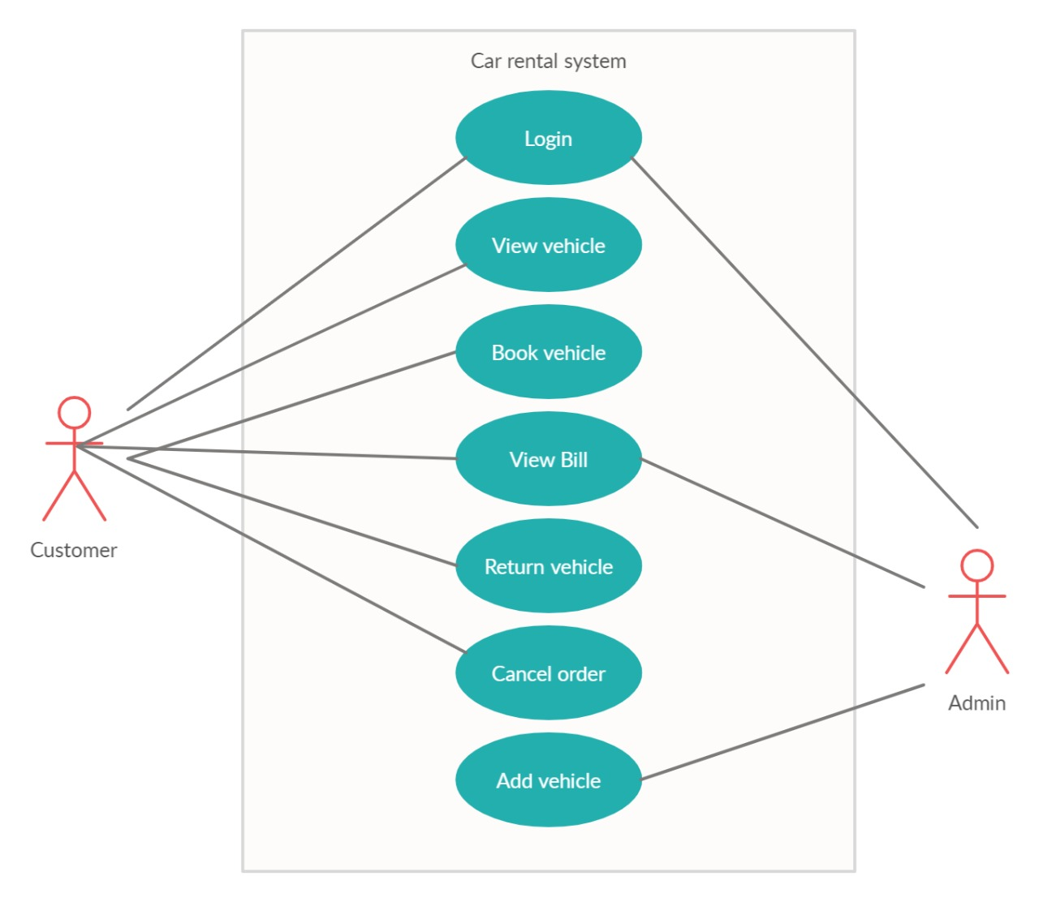

**3.2 Activity Diagram –**

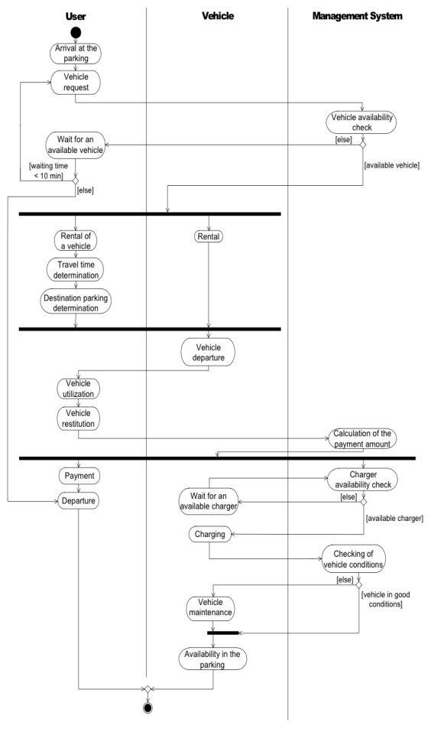

**3.3 Sequence Diagram –**

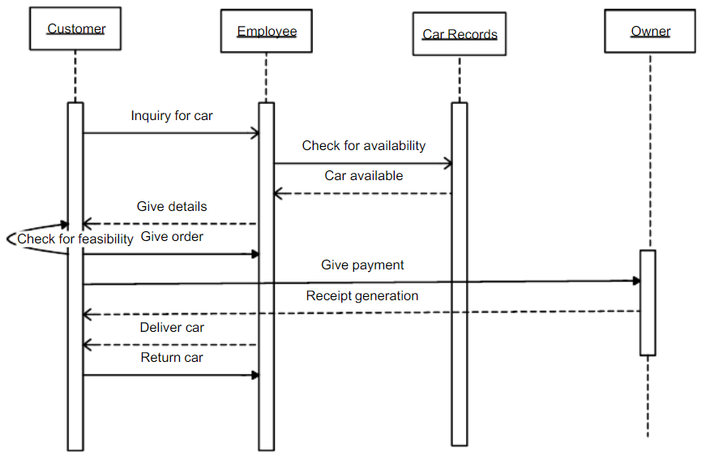

**3.4 E-R Diagram –**

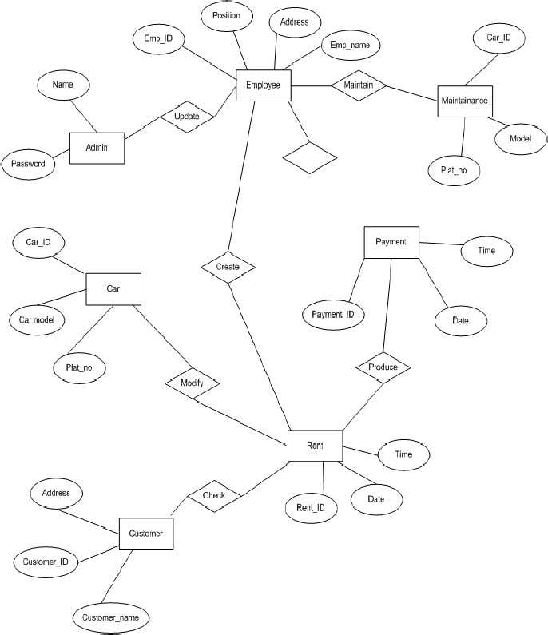

**3.5 Implementation –**

**3.5.1 Logical Structure of Data –**

For Customer –

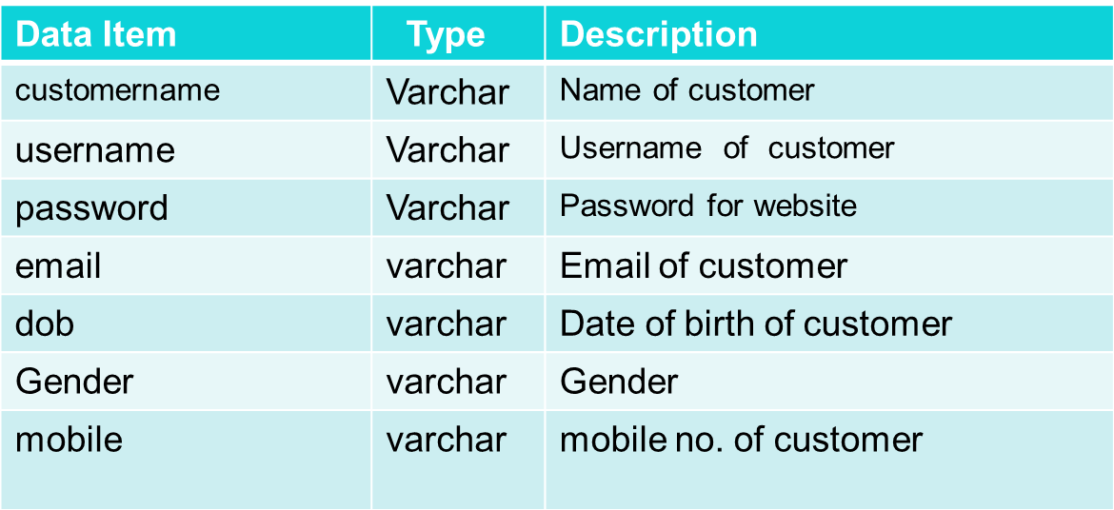

For Feedback –

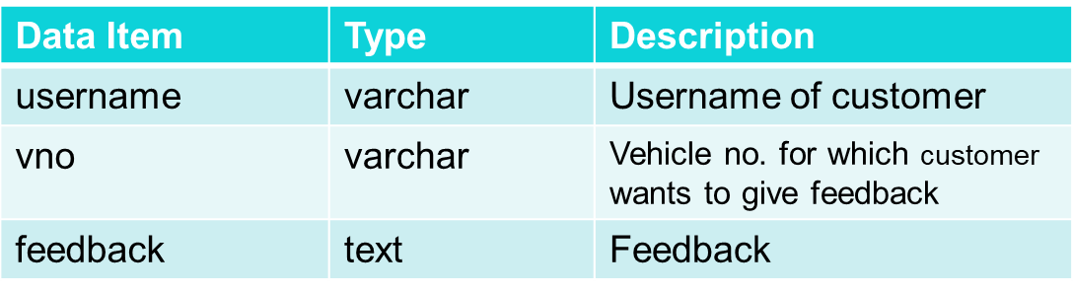

For Vehicles –

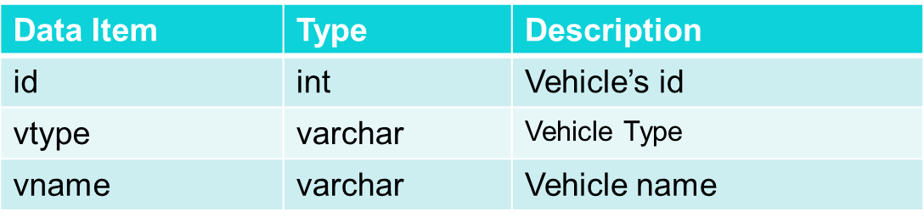

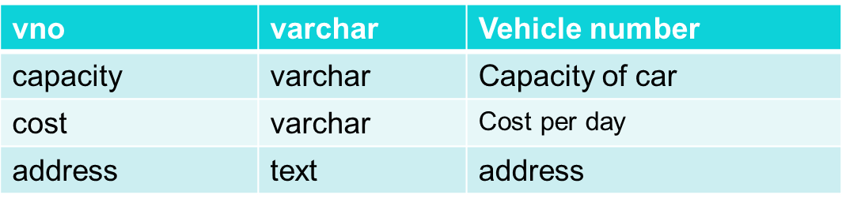

For Booking –

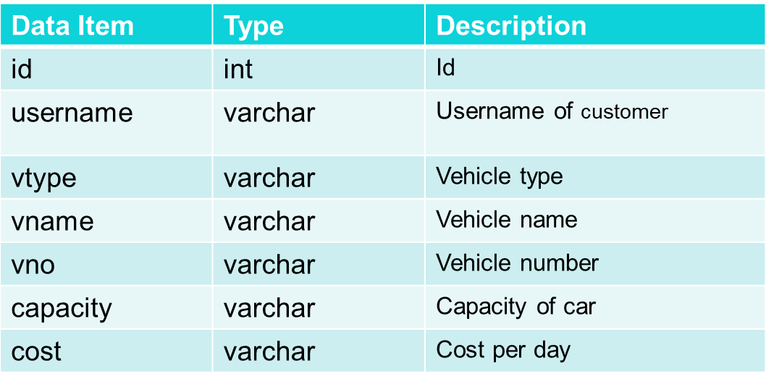

Booking Table Continues.

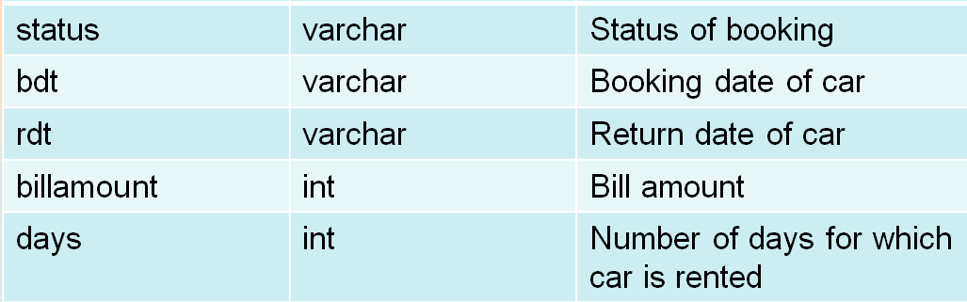

**CHAPTER 4: CONSTRUCTION**

**4.1 Validation –**

Validation is done to check whether all functional and performance requirements are met. Validation is the documented process of demonstrating that a system or process meets a defined set of requirements. There are a common set of validation documents used to provide this evidence. A validation project usually follows this process: Validation Planning – The decision is made to validate the system. Experience in project management can assist supervisors in evaluating the different phases and steps of validation. We tested validation by –

1] Ensuring Log in is working correctly with right password only as well as user is able to do Log out without any problem.

2] Ensuring Administrator is able to add Car in list of available Cars for customer.

3] Customer is able to Rent Car and there is no bug related to booking.

4] Checking whether bill is generated properly as well as customer is able to see his/her past books/tracking history.

**4.2 Testing –**

**4.2.1 Black Box Testing –**

For testing the project we used “BLACK BOX TESTING” technique in which only person who knew code is doing testing else outsiders are not familiar with code inside.

This method enables the software engineer to device sets of input techniques that fully exercise all functional requirements for a program. Black box testing tests the input, the output and the external data. It checks whether the input data is correct and whether we are getting the desired output.

We will start by using both static and dynamic testing strategies. The static strategies will include reviewing the basics of the application whereas the dynamic testing is based on actual code execution.

The features we tested were as follows:

● To ensure that the application itself ran (Dynamic)

● log-ins worked efficiently and consistently (Dynamic)

● accessing the web application from multiple platforms to ensure cross compatibility (Dynamic)

● checking page load time (Dynamic)

And more….

**CONCLUSION AND FUTURE WORKS**

**Conclusion –**

Our project is only a humble venture to satisfy the needs to manage their project work. Several user friendly coding have also adopted. This package shall prove to be a powerful package in satisfying all the requirements. The objective of software planning is to provide a frame work that enables the manger to make reasonable estimates made within a limited time frame at the beginning of the software project and should be updated regularly as the project progresses.

**At the end it is concluded that we have made effort on following points…**

1] A description of the background and context of the project and its relation to work already done in the area.

2] Made statements of the aims and objectives of the project.

3] The description of Purpose, Scope and applicability.

4] We define the problem on which working on the project.

5] We describe the requirement Specifications of the system and the actions that can be done on these things.

6] We understand the problem domain and produce a model of the system, which describes operations that can be performed on the system.

7] We designed the user interface and security issues related to the system.

8] Finally the system is implemented and tested according to test cases.

**Future Works**

In a nutshell, it can be summarized that the future scope of the project circles around maintaining information regarding:

1] We can add printer in future.

2] We can give more advance software for Car Rental System including more facilities.

3] We will host the platform on online servers to make it accessible worldwide.

4] Implement backup mechanism for taking backup of codebase and database on regular basis on different servers.

The above mentioned points area the enhancements which can be done to increase the applicability and usage of this project. Here we can maintain the records of Car and Car Company. Also, it can be seen that now-a-days the players are versatile.

We have left all the options open so that if there is any other future requirement in the system by the user for the enhancement of the system then it is possible to implement them. In the last we would like to thanks all the persons involved in the development of the system directly or indirectly. We hope that the project will server its purpose for which it is develop there by underlining success of process.

**APPENDIX A (SNAPSHOT) -**

Following are some of the snapshots of our project in working condition –

**For Home Page**

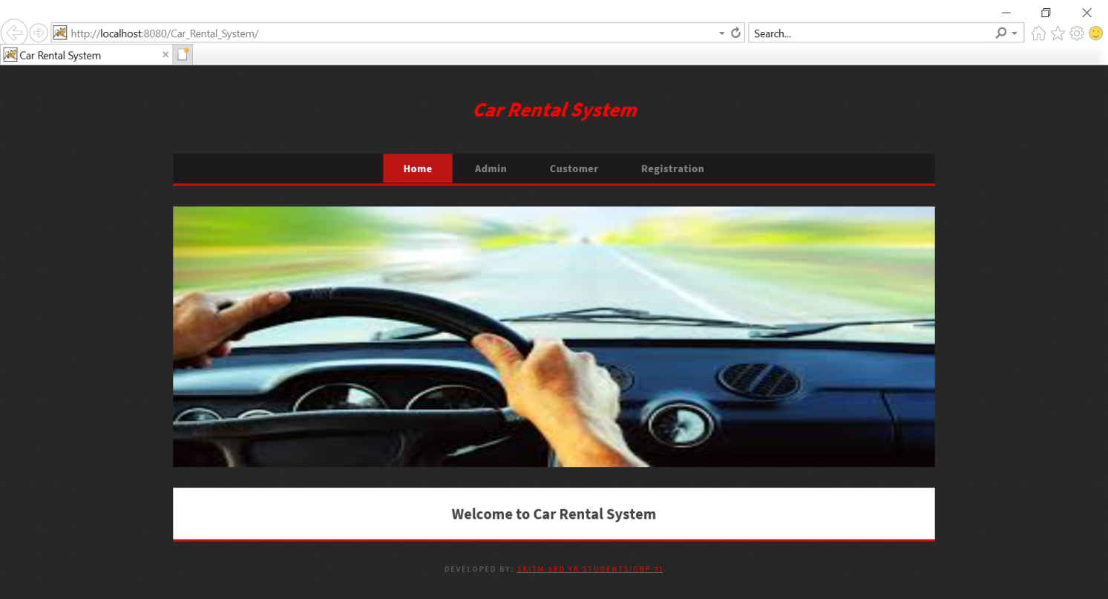

**Registration Page –**

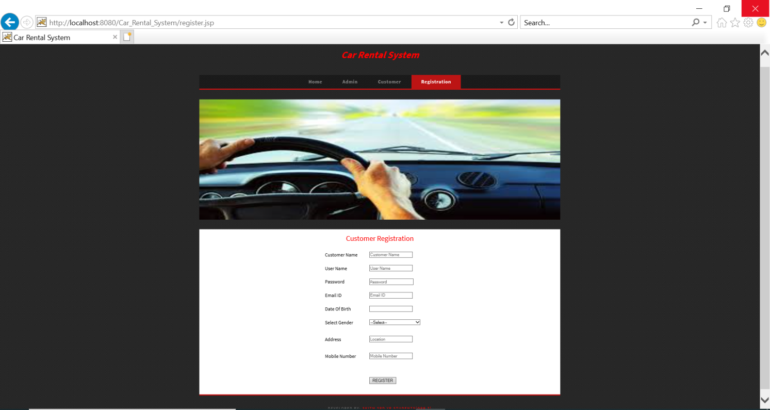

**ADMIN PAGE –**

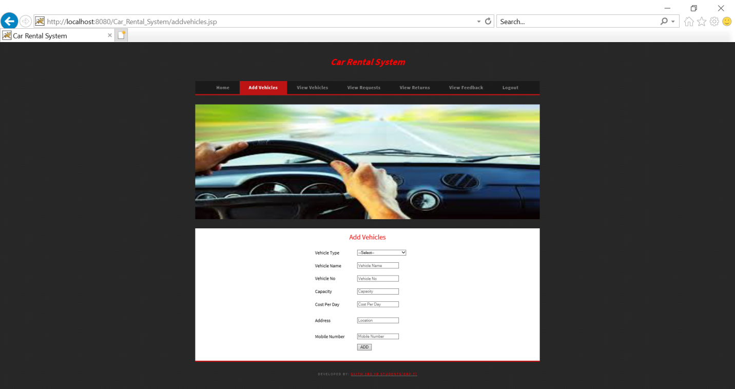

**CUSTOMER MODULE PAGE –**

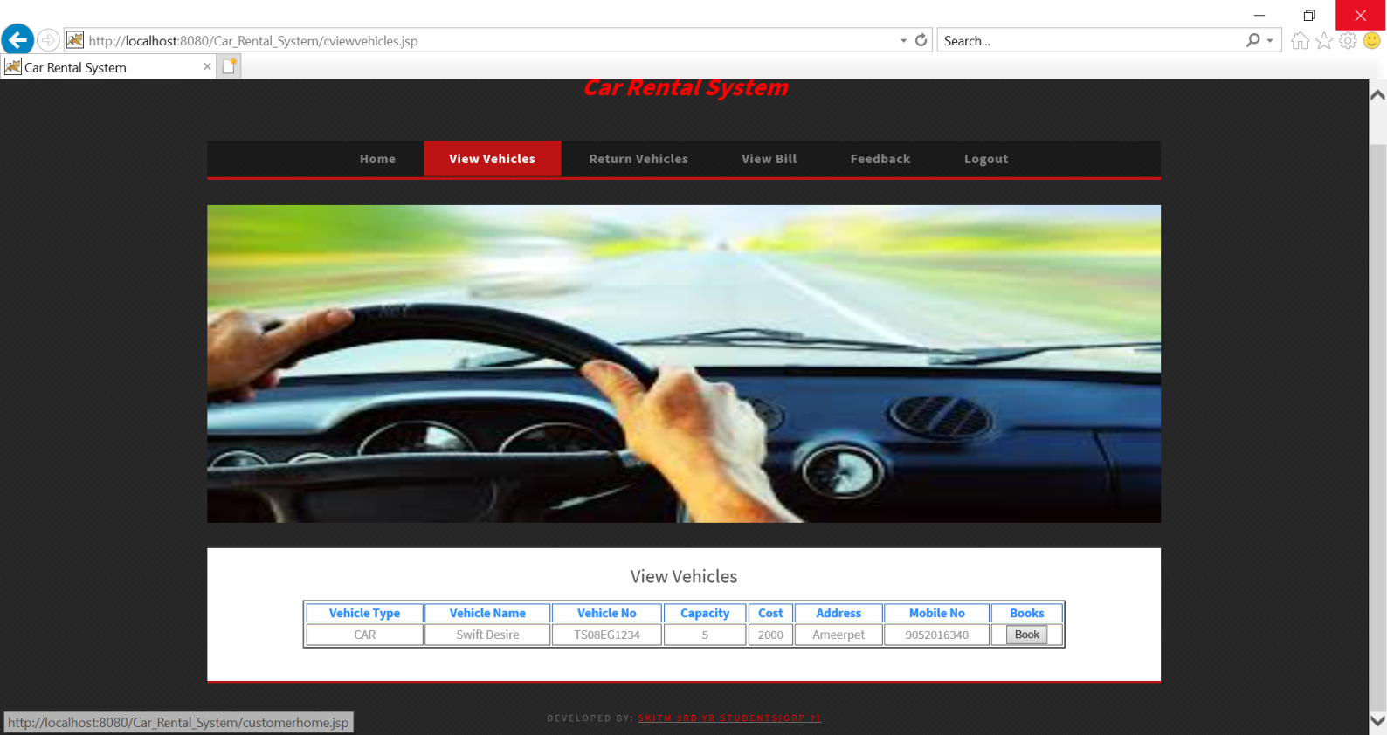

**REFRENCES**

1] GFG.

2] Wikipedia.

3] Quora.

4] Oracle guide for Database connectivity.

5] StackOverflow.

6] Microsoft Docs.

7] Youtube.

8] Xampp.com

9] Oracle documentation for Java.

10] TutorialPoint.